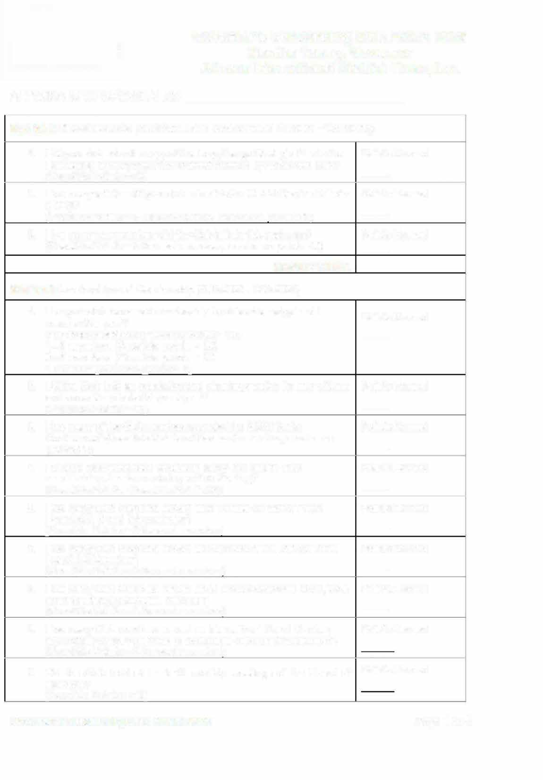
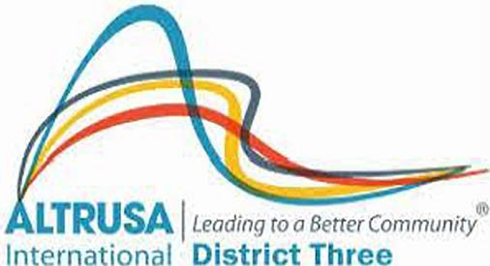
Governor's Outstanding Club Award 2026 Mantha Young, Governor
Altrusa International District Three, Inc.

ALTRUSA INTERNATIONAL OF
2.
3.

Section I: Biennium Goals (Must have been done between 2/1/2025 - 1/31/2026))
1. Did your club post at least once per month to your club's social media platforms during the year?  (Possible Points = 2 per month, Maximum Points = 20) | Points Earned  --
How many articles did your club submit to the District Service Bulletin (DSB)?  (Possible Points = 5 for each article, maximum points 20)  How many new members did the Club initiate this past year?  (Possible Points = 5 for each member, maximum points 20)  Section I TOTAL  Section II: Leadership and Membership (2/01/2025 -1/31/2026)  1. Has your club increased membership this year over last year?  7 or more members (Points = 20) 5 -6 members (Points = 15)  3 - 4 members (Points = 10)  1 member (Point = 5)  2. Did the Club hold an orientation and planning session for new officers and committee chairs this past year?  (Possible Points = 10) | Points Earned
 | --
Points Earned
--
 | Points Earned
 | --
 | Points Earned
 | --
3. How many of the Club members attended the 2025 District  Conference? (Possible Points = 5 for each member, maximum points 25) | Points Earned  --
4. Did your club submit a copy of the Long-Range Strategic Plan to the  the Governor by November 30th? (Points = 20) | Points Earned  --
- How many Club members served as a Trustee of District Three Foundation Board this past year?  (Possible Points = 3 for each member)  - How many Club members served as members of the District Three Board this biennium?  (Possible Points = 3 for each member) | Points Earned
 | --
 | Points Earned
 | --
7. How many Club members served as a District Committee Chair, Vice Chair or District committee member?  (Possible Points = 3 for each member) | Points Earned  --
8. How many Club members served as International Board Member, Committee Chair, Vice Chair or Committee member this biennium?  (Possible Points = 3 for each member) | Points Earned
9. Did the Club hold at least 10 monthly meetings of the Board of Directors?  (Possible Points = 10) | Points Earned
Governor's Outstanding Club Award 2026 Page 1 of 4

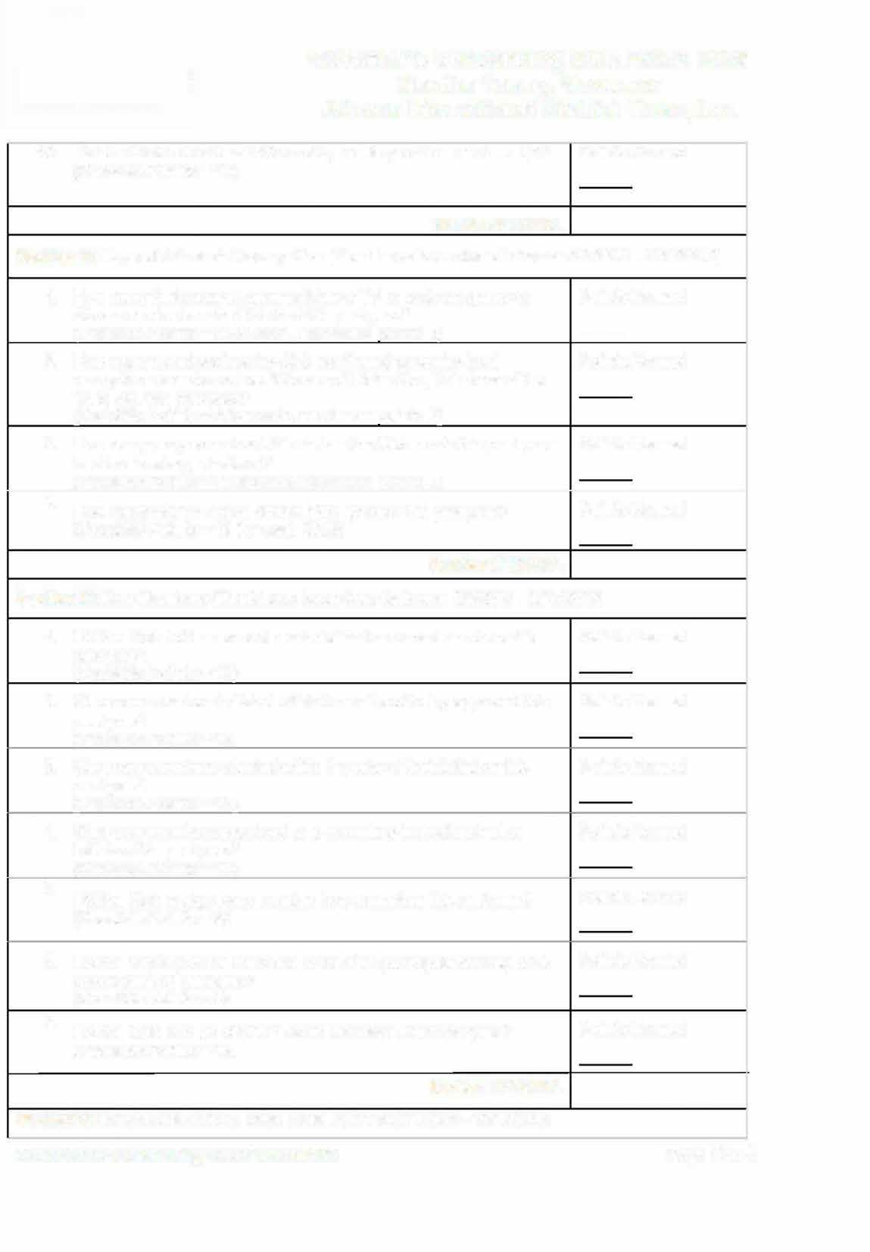
Governor's Outstanding Club Award 2026 Mantha Young, Governor
Altrusa International District Three, Inc.

10. Did the Club hold at least 10 monthly meetings of the membership? Points Earned (Possible Points = 10)

Section II TOTAL
Section Ill: Expand Altrusa's Recognition (Must have been done between 2/1/2025 -1/31/2026)

- How many feature newspaper articles or TV or radio programs on Points Earned
Altrusa service has the Club had this past year? --
(Possible Points = 2 for each, maximum points 8)
- Does the Club have Social Media presence? Points Earned
Facebook - 10 points, Instagram - 5 points..
(Possible Points are 15)

- Did you post at least once monthly? Points Earned
Facebook - 10 points, Instagram - 10 points. (Possible points 20)
4. How many ASTRA Clubs did the Club sponsor this past year? Points Earned (Possible Points = 15 for each Club)
Section Ill TOTAL
Section IV: New Members (Must have been done between 2/1/2025 -1/31/2026)

- Did the Club hold an annual reorientation for current members this Points Earned
past year?
(Possible Points = 10)
- Were new members initiated within 2 months of being approved this Points Earned
past year?
(Possible Points = 10)
Were new members oriented within 6 weeks of their initiation this past year?  (Possible Points = 10) | Points Earned
4. Were new members appointed to a committee immediately after initiation this past year?  (Possible Points = 10) | Points Earned
5. Did the Club assign every member to a committee this past year?  (Possible Points = 5) | Points Earned
- Did the majority of the members of the Club participate actively on a committee this past year?  (Possible Points = 5)  - Did the Club hold an official "Add an Altrusan" event this year?  (Possible Points = 10)  Section IV TOTAL  Section V: Service (Must have been done between 2/1/2025 -1/31/2026) | Points Earned  Points Earned
Governor's Outstanding Club Award 2026 Page 2 of 4
3.

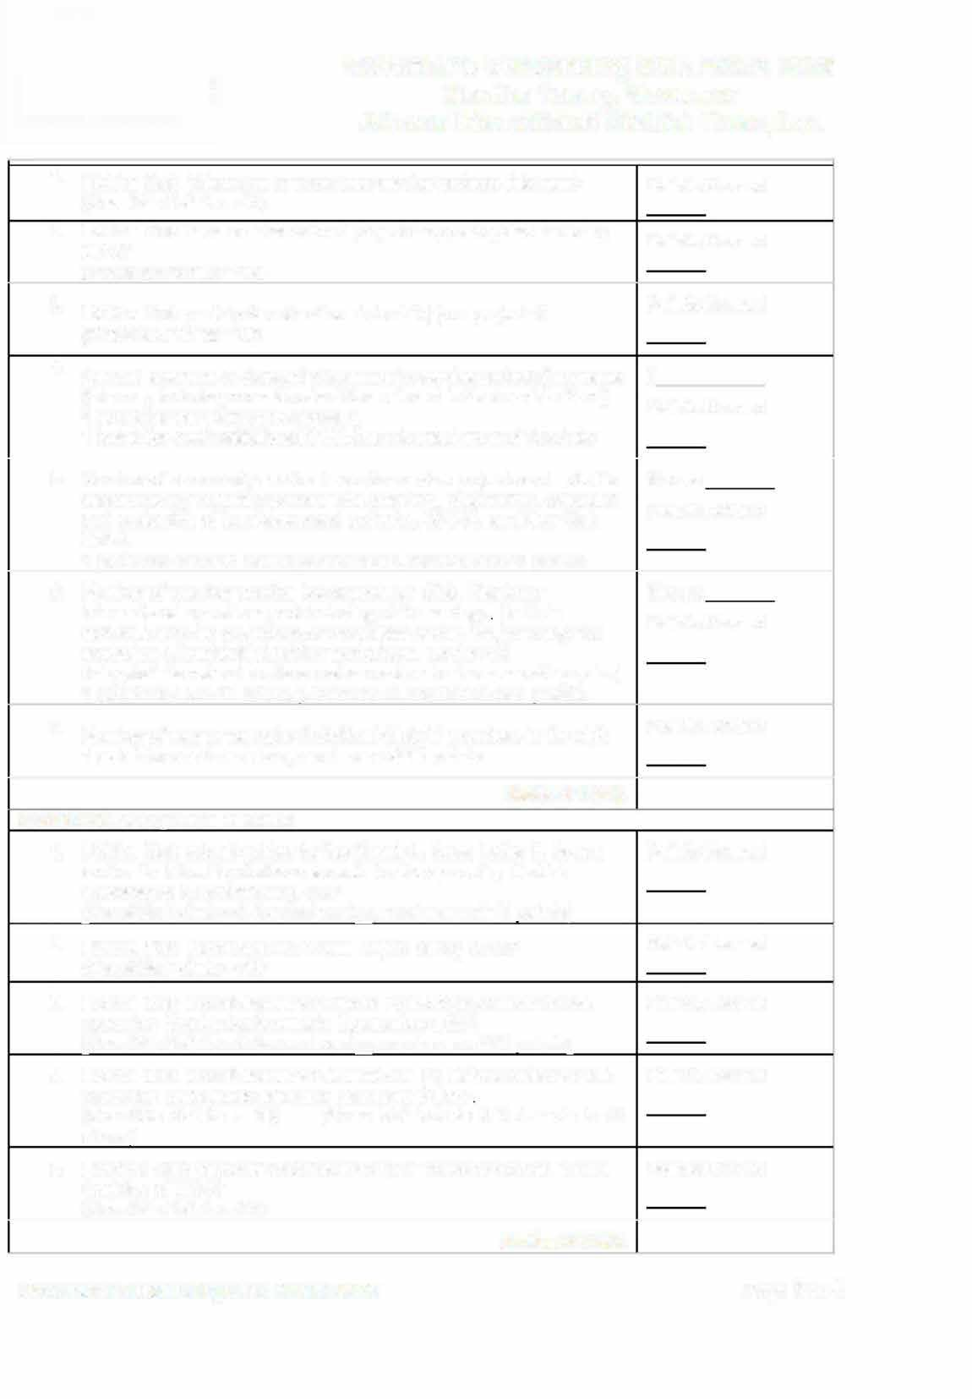
Governor's Outstanding Club Award 2026 Mantha Young, Governor
Altrusa International District Three, Inc.
3.
5.

- Did the Club initiate one or more new service projects this year?  (Possible Points = 10)  - Did the Club have an international project they participated in during the year?  (Possible Points = 10) | Points Earned  Points Earned
Did the Club participate with other civic club(s) on projects? Points Earned (Possible Points =10)
4. Amount spent on or donated to community service projects/programs $
(this may include your estimate of the value of in-kind contributions) Points Earned 5 point for the first $500 donated,
1 point for each additional $500 up to maximum of 3 points
Number of community service hours for service projects and activities #hours sanctioned by Altrusa (includes time planning, preparation, execution Points Earned
and evaluation of fundraisers and projects, ASTRA, and New Club
Build).
1 point for each 10 hours per member, maximum of 5 points
6. Number of member service hours spent on Club, District or International operations, not including club meetings (Include activities such as production of newsletter or website, planning and execution of leadership/training workshops, serving as delegate/alternate at conference/convention business meetings, etc.)  1 point for each 10 hours per member, maximum of 5 points | #hours  Points Earned
7. Number of new or renewing individual Club 21 members in the club.  1 point for each member, maximum of 10 points | Points Earned
Section V TOTAL
Section VI: Recognition of Clubs  - Did the Club submit entries for the Mamie L. Bass, Letha H. Brown and/or Dr. Nina Fay Calhoun awards for the upcoming District Conference in Spartanburg, SC?  (Possible Points = 5 for each entry, maximum of 15 points  - Did the Club submit a Club Annual Report during 2025?  (Possible Points = 20)  - Did the Club submit entries for District Foundation Awards for the upcoming District Conference in Spartanburg, SC?  (Possible Points = 5 for each entry, maximum of 25 points)  Did the Club submit entries for at least one (1) District Award for the upcoming District Conference in Spartanburg, SC?  (Possible Points = 10) (Does Not include Int'/ Awards in #1  above)  Did your Club become "Club Level Club 21" member with an annual donation of $210?  (Possible Points = 20) | Points Earned  Points Earned Points Earned  Points Earned  Points Earned
Section VI TOTAL
Governor's Outstanding Club Award 2026 Page 3 of 4
5.
4.

Governor's Outstanding Club Award 2026 Mantha Young, Governor
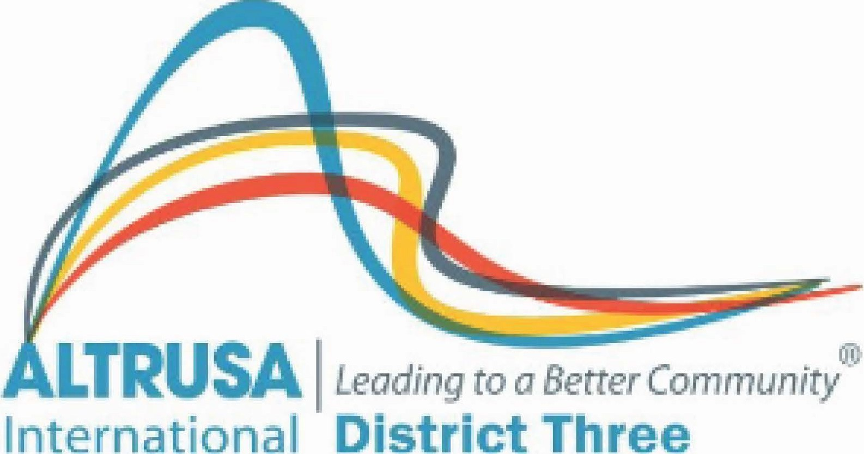

Altrusa International District Three, Inc.

TOTAL POINTS EARNED

FORM COMPLETED BY:
DATE _

I encourage all our clubs of Altrusa District Three to send in this application entry for this award. Completing this form will also assist you in submitting the Club Annual Report in 2026, as some of the same information is requested.
By applying for this award, you demonstrate how essential your club's service is to your community and beyond while allowing recognition for all you accomplish. Like bees working together to build a thriving hive, we can achieve incredible things together. I encourage you and your members to embrace every opportunity to continue "Beeing Essential" and make a difference in your local Hive!

Deadline for applying: February 28, 2026

Mantha Young, Governor
Email: governordistrictthree@gmail.com or mail to:

Mail: Mantha Young, Governor
Altrusa International District Three, Inc. 8513 SE 123rd Court
Jasper, FL 32052

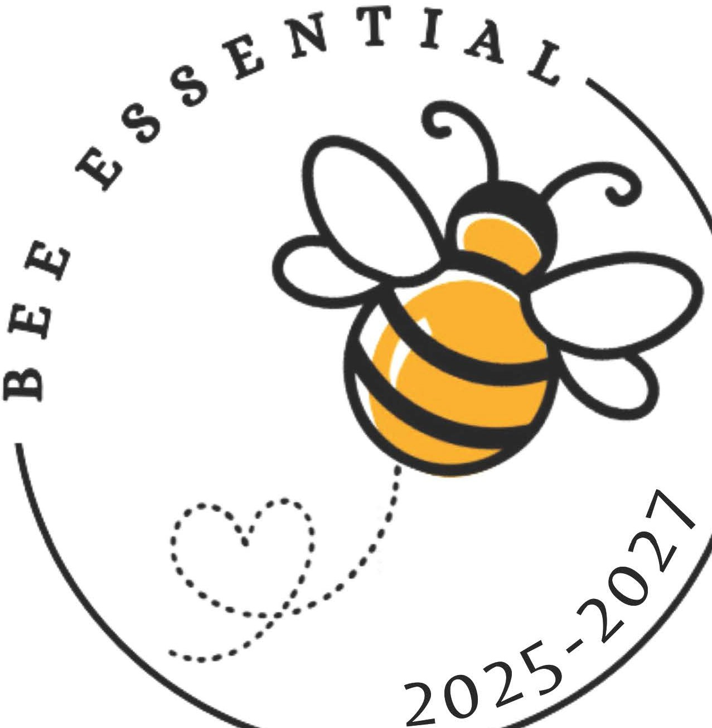

Page 4 of 4

