IN MEMORIUM FORM

For Clubs Reporting Members who have Passed
DUE MARCH 18, 2026

CLUB NAME: Altrusa International of ___________________________________________________________
NAME OF DECEASED MEMBER: _______________________________________________________________
DATE OF DEATH: ___________________________________________________ AGE: __________________
MEMBER OF ALTRUSA SINCE ______________________ (approximate if unsure)

CONTRIBUTIONS TO ALTRUSA AND THIS CLUB INCLUDE:
Please provide remarks for the Conference Speaker (approximately 1-2 minutes).
__________________________________________________________________________________________
__________________________________________________________________________________________
__________________________________________________________________________________________
__________________________________________________________________________________________
__________________________________________________________________________________________
__________________________________________________________________________________________
PLEASE INCLUDE A PHOTO FOR USE AT THE CONFERENCE MEMORIAL PRESENTATION

CONTACT PERSON SUBMITTING THIS FORM: (Club President or Treasurer)
NAME: ____________________________________________________________________
EMAIL ADDRESS: ___________________________________________________________
TELEPHONE: _______________________________________________________________
CLUB POSITION: ____________________________________________________________

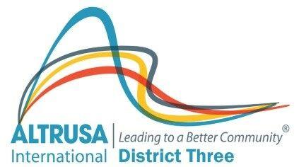
PLEASE SEND COMPLETED FORM AND PHOTO TO:
DISTRICT THREE SECRETARY: Nanci Schwartz
918 Hawk Landing
Fruitland Park, FL 34731
napschwartz@gmail.com

