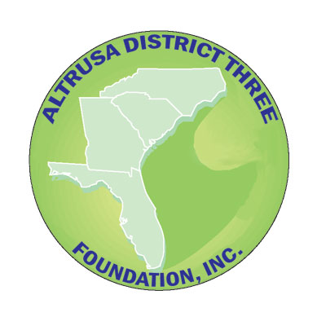

JOEY ROBISON SCHOLARSHIP FOR NON-TRADITIONAL STUDENTS APPLICATION

Altrusa International of _________________________________

Name___________________________________________________________________________________
Last First Middle

Address _________________________________________________________________________________
Street or PO Box City State Zip Code

Telephone_____________________(day) ________________________ (night)

Email Address____________________________________________________________________________

Graduated from __________________________________________ High School in (year)______________

OR received GED in (year) ____________________

Presently attending ______________________________________ and plan to graduate in ____________
Name of college/university/tech school Year

with an undergraduate _________________________degree in ___________________________________

Are you employed? □ yes □ no
If yes, place of employment? __________________________________ position? ______________

If single, what is your personal annual gross income? _________________

If married, what is your family’s annual gross income? ________________

How many people does this reported income support? __________________

Use an attached sheet to complete your responses to the following.

1. Describe your goals and plans for the future.

2. Describe your present financial aid and your financial need.

*Application and 2 references must be emailed or postmarked on or before _____________ and sent to:
Joey Robison Scholarship for Non-Traditional Students,
Altrusa International of ______________________ at email/address_______________________________

An applicant should be:
*A resident of ___________________ County who plans to remain in the area,
*A non-traditional student (out of high school for six or more years) seeking to upgrade work skills, and
*An individual who has serious financial need seeking an undergraduate degree.

Incomplete application packets will not be considered.

(Updated 10-25)

