Altrusa District Three Foundation, Inc.
RECIPIENT GUIDELINES
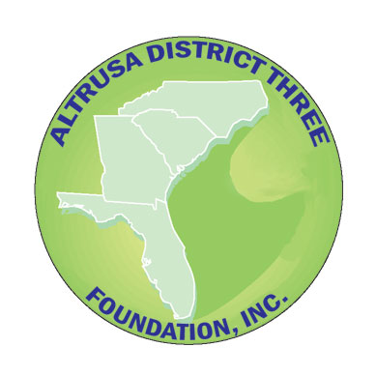

JOEY ROBISON SCHOLARSHIP FOR NON-TRADITIONAL STUDENTS

Altrusa International of

Altrusa International is a volunteer service organization that focuses on improving the educational level of citizens of County. The Joey Robison Scholarship for Non-Traditional Students was named in memory of the son of Linda Robison, former Governor, Altrusa International District Three, Inc. Mrs. Robison is an avid supporter of higher education and believes Altrusa must give a hand up to individuals with not only educational needs but also a desire to change and improve the condition of their lives.

Each Joey Robison Scholarship for Non-Traditional Students assists an undergraduate student who is enrolled in an accredited institution of higher education. Scholarships of $500 each will be awarded to a qualified applicant chosen and approved by a committee of the Altrusa District Three Foundation, Inc. Scholarship awards are announced at Conference, where the check is presented to the submitting CLUB and made out to the school of the winning applicant.

An applicant should be:
- a resident of County who plans to remain in the area.
- a non-traditional student (out of high school for six or more years) who seeks to upgrade work skills in a tech school or college to seek an undergraduate degree.
- an individual who has serious financial need.

Non-traditional students who wish to be considered must:

- Complete the application form.

- Ask two people to submit recommendations on the provided form. Each person should be a professional with knowledge of the applicant’s academic grades and be familiar with the applicant’s academic ability and commitment to finishing a degree. Recommendations from family members will not be considered.

The applicant should give the form to the individuals who will make a recommendation. The person completing the recommendation should email or mail the reference directly to the Altrusa club.

A complete application packet is the application form and two (2) completed recommendations. Incomplete packets will not be considered. Applicants may need to follow-up with people asked to make references to be sure the recommendations are emailed or mailed on time to the Club.

The Grants & Scholarship Committee of the District Three Foundation will make the selection. All winning applicants will be announced at the Altrusa District Three Conference.

Send Complete Packet to Club: Altrusa International of ____________________________________

Email or Address: ____________________________________________________________________
Applications & Recommendations must be emailed on or before _______________.

(Updated 10-25)

