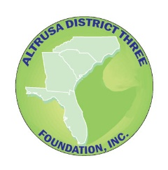

Altrusa District Three Foundation, Inc.

Information for Clubs

The Joey Robison Scholarship for Non-Traditional Students

This scholarship is for undergraduate non-traditional students. What does this mean? -- If the student is attending college or tech school at a later time due to circumstances such as a divorce and need for a better education, financial hardship, necessary change of career, or other limitations, then this is a non-traditional student. The student should be out of high school for 6 or more years.

The scholarship amount is $500. The number of scholarships to be awarded is dependent on funds available in this restricted District Three Foundation account. No more than one scholarship per year per club may be awarded. Applications must be postmarked by January 31st, and scholarship awards are announced at Conference, where the check is presented to the submitting CLUB and made out to the school of the winning applicant.

“Leading to a Better Community” is our International tagline and this scholarship is certainly a great way to better your community one person at a time. Clubs should strive to make the scholarship information available to individuals and schools in their community in a timely manner.

The club should download the Guidelines, Information, Recommendations and Application documents from the Altrusa District Three website, Foundation page, and provide these to either a qualified student or local schools for posting. After the application, with supporting documentation, has been received and approved by the Club, all paperwork should be forwarded to Altrusa District Three Foundation, Inc. at district3foundationgrants@gmail.com for final submission and approval.

As long as Clubs and individuals continue to support this scholarship through donations, individuals in your communities have the opportunity to further their education with the aid of this scholarship.

If you have questions concerning this scholarship, please contact the Altrusa District Three Foundation Grants & Scholarship Committee at district3foundationgrants@gmail.com all completed packets from Clubs are due by January 31st.

(Updated 10-25)

