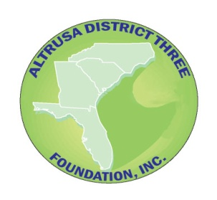 **Altrusa District Three Foundation, Inc.**

Thank you for donating to our 2026 Silent Auction

Please provide us with the following information so that we may properly

recognize your gift. Please bring your item with you to Conference.

All donations benefit District Clubs thru Grants and Awards.

**ITEM NAME:**

**Brief Description** (Please be as detailed as possible, this is used to describe the item on the Bid Sheets)

_____________________________________________________________________________________________

**DONOR NAME** (Please Print)

**_____________________________________________________________________________________________**

**CLUB NAME**

______________________________________________________________________________

**ADDRESS** (City, State, Zip)

______________________________________________________________________________

**EMAIL ADDRESS**

**_____________________________________________________________________________**

**ESTIMATED RETAIL VALUE OF ITEM RECOMENDED MINIMUM BID**

**$____________________________ $____________________________**

A letter of acknowledgement for your tax records will be sent after the event. Altrusa District Three Foundation, Inc. is a 501(c)3 not for profit organization.

Please complete this form and return it to:

Shannon Schell, Treasurer at: [seszippy@aol.com](mailto:seszippy@aol.com)

**Thank You for your support!**