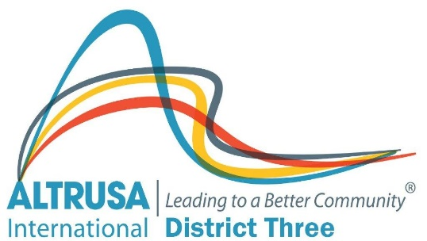

ALTRUSA INTERNATIONAL DISTRICT THREE, INC.
District Three Extension Award

District Three has taken a proactive role in addressing the decline in club memberships by developing a strong plan for club extensions. This plan includes training materials and a support system available through the District Three Board and New Club Building Committee.
The District Three Extension Award, given at the time a new club is chartered, recognizes and rewards the Supporting Club for its efforts to keep Altrusa International a growing organization and to expand awareness of Altrusa as a vital part of the service community. The award system described below encourages both growth and expansion. It is important to promote the value of “giving Altrusa away.” Promoting the idea that Altrusa is an outstanding organization for qualified leaders allows us to give away the best we have to offer. Therefore, growth becomes an integral part of our District Three success and our clubs all benefit from the recognition.
Criteria for District Three Extension Award
- Points are given to the Supporting Club for the date on which a club is chartered, using the date of the most recent conference as a reference. Thus, a Supporting Club will receive three points for a club chartered on the earliest date after April 30th, the next earliest chartered club will provide two points, and the third earliest will provide one point.
Earliest: 3 points (first club chartered after April 30)
Second Earliest: 2 points (second club chartered after April 30)
Third Earliest: 1 point (third club chartered after April 30)

- The Supporting Club receives two points for each Charter Member
Example: 15 Charter Members = 30 points 25 Charter Members = 50 points

- One point is given for each additional, non-charter member of the club as of the April 1 deadline date (immediately prior to Conference)
Example: 24 members = 24 points

- First, Second, and Third place winners receive certificates.

