 | Altrusa International District Three, Inc.  Strategic Plan - 2023-2025 | 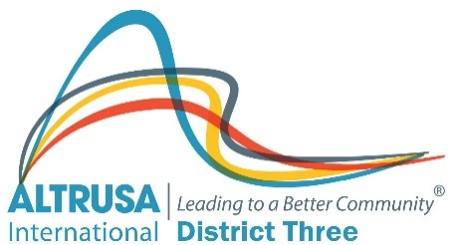

Vision: Altrusa is a leader among international organizations improving communities worldwide through a network of member clubs. | Mission: To improve communities worldwide by providing service, developing leadership, fostering international understanding and encouraging fellowship through an international network of dedicated volunteers. | Brand: Leading to a Better Community  Brand Anchors:  Flexibility, Inclusion, Clarity | Measures:  1.Member Numbers  2.Member Satisfaction Rating  3.Service Hours and Fundraising $  4.Website hits  5.Social Media Connections

Service  Inspire profile enhancing Service Projects |  | Facilitate the sharing of service project ideas |  | - Support a District Service Project and International’s “Days for Girls”
 |  |  |  | - Seek out new opportunities for addressing Literacy needs in our communities
 |  |  |  | - Inspire service projects/fundraisers through a data base/tool kit
 |  |  |  | - Encourage new more flexible & inclusive service projects
Marketing  Enhance the flow of Altrusa information internally and with external parties |  | Enhance bi-directional flow of information within Altrusa |  | - Share information through the District Service Bulletin  - Collect feedback via on-line surveys (Members to District)
 |  |  |  | - Enhance marketing plan including best practice guides/tool kits
 |  | Promote Altrusa to communities worldwide |  | - Enhance social media strategy/policy to communicate with prospects & members.
 |  |  |  | - Enhance District website for potential members & intuitive one for members.
Members  Increase membership Numbers to 800 members by 2024 |  | Recruit & Retain a diverse membership |  | - Embrace change and diversity  - Expansion of ASTRA clubs with focus on transition to Altrusa
 |  |  |  | - Improve resources for the effective recruiting of new members
 |  |  |  | - Promote activities that are attractive to potential and younger members
 |  |  |  | - Engage members in their Altrusa journey via service & personal interactions
Leaders  Create a pipeline of strong Altrusa Leaders |  | Develop leadership at all levels of Altrusa |  | - Cultivate a training track for new leaders (train the trainers)
 |  |  |  | - Enhance tools/best practice guidelines to build new leaders
 |  |  |  | - Support the mentoring programme
 |  |  |  | - Encourage succession planning at all levels
Member Service  Inform, Update and Educate members |  | Respond to member needs in a timely manner |  | - Enhance collection and reporting of membership data through Group Tally
 |  |  |  | - Produce tools/resources to support District/Clubs and members
 |  |  |  | - Provide District Service Bulletin, District Website, District workshops, email communications and other services

