MEMORIAL FORM
For Clubs Reporting Members who have Passed
DUE MARCH 15, 2024

CLUB NAME: Altrusa International of ___________________________________________________________
NAME OF DECEASED MEMBER: _______________________________________________________________
DATE OF DEATH: ___________________________________________________ AGE: ___________________

MEMBER OF ALTRUSA SINCE ______________________ (approximate if unsure)

CONTRIBUTIONS TO ALTRUSA AND THIS CLUB INCLUDE:
(What a representative would say in 1-2 minutes)
__________________________________________________________________________________________
__________________________________________________________________________________________
__________________________________________________________________________________________
__________________________________________________________________________________________
__________________________________________________________________________________________
__________________________________________________________________________________________
PLEASE INCLUDE A PHOTO FOR USE AT THE CONFERENCE MEMORIAL PRESENTATION

CONTACT PERSON SUBMITTING THIS FORM: (Club President or Treasurer)
NAME: ____________________________________________________________________
EMAIL ADDRESS: ___________________________________________________________
TELEPHONE: _______________________________________________________________
CLUB POSITION: ____________________________________________________________

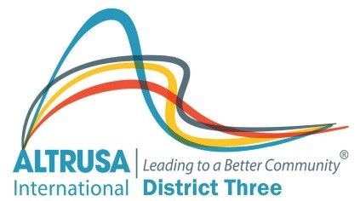
PLEASE SEND COMPLETED FORM AND PHOTO TO:

DISTRICT THREE SECRETARY: Amanda Seyfang
PO BOX 58
Starke, Fl. 32091
aseyfang@gmail.com

