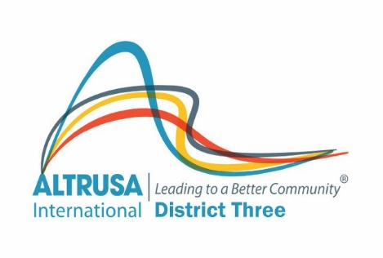
ALTRUSA INTERNATIONAL DISTRICT THREE, INC.
CLUB REVITALIZATION GRANT PROGRAM
2021-2022

Background/Purpose: In 2011, recognizing the need to support under charter strength clubs in District Three, the Board of Directors voted to allocate the $2,500.00, raised by Clubs and member donations to honor then Immediate Past Governor Robin Hall for the express purpose of growing membership in under charter strength clubs. The Board continues to support this effort and allocates funds for the Grant. There are currently five (5) under charter strength clubs in District Three.
The Board agreed that the most equitable distribution of funds would be achieved via a competitive grant process. This process would also help to ensure that clubs seeking assistance would have an opportunity to carefully assess their needs and seek out the kind of assistance that would be most meaningful for their particular situation. The Board of Directors also felt that a club willing to do some amount of work in terms of evaluating their needs and preparing the grant application might be more likely to achieve a successful outcome.

All under charter strength clubs in District Three may submit a grant proposal for consideration by the Board of Directors of Altrusa International District Three, Inc.

Eligibility: Clubs must meet the following eligibility criteria.
• Club must be under charter strength (less than 15 members)
• Club must submit a written plan, with benchmarks for revitalizing and achieving charter strength
• Club must be willing to work with assigned District Representative to achieve goals as stated in their revitalization plan
• Club will report back to board after event/project evaluating outcome by April 15, 2022.
• Additional consideration may be given to clubs that have submitted and implemented a strategic plan.

Submission of Applications: Completed application forms must be postmarked or submitted electronically NO LATER than September 1, 2021. Applications should be signed and dated by the President of the Club. Email applications are acceptable, provided the e-mail is sent from the club president.
Applications should be sent to:
Dinah Henderson 5336 Meadow Hill Loop, Lady Lake, FL 32159
dinahehenderson@centurylink.net
ALTRUSA INTERNATIONAL DISTRICT THREE, INC.
CLUB REVITALIZATION GRANT PROGRAM
GRANT APPLICATION FORM

Date: _________________________________________________________________________________

Submitted by: Altrusa International of ______________________________________________________

President: _____________________________________________________________________________

Address: ______________________________________________________________________________

Work Phone: __________________________ Home Phone: ____________________________________

E-mail Address: ________________________________________________________________________

Number of Club Members as of Application Date: ____________________________________________

Last Year Club was at Charter Strength: ____________________________________________________

How frequently does club meet? __________________________________________________________

Has Club adopted and implemented a strategic plan? ________________________________________

If “yes”, when was it adopted? ____________________________________________________________

If “no”, is a plan currently being developed? ________________________________________________

Last date progress towards goals was evaluated? ___________________________________________

Date of last recruitment event? __________________________________________________________

Date of last orientation/reorientation program? _____________________________________________

Please list current service projects: _______________________________________________________

_____________________________________________________________________________________

Please list current fund-raising activities:

_____________________________________________________________________________________

Please describe your major obstacle to growth in membership: ________________________________
_____________________________________________________________________________________
_____________________________________________________________________________________
Please describe your Club’s plan for revitalization including specific goals, a time line, and list of people who will be responsible for each task:
Goal | How will it be achieved? | Who will be responsible? | When will it be completed?

Total amount of funding requested: _________________________

Please explain how funds will be used: ____________________________________________________

_____________________________________________________________________________________

_____________________________________________________________________________________

_____________________________________________________________________________________

Dollar Amount Requested | Purpose

Funds may be used for such things as printing of invitations or brochures for recruitment event, postage, refreshments for recruitment event, advertisements in local media, purchase of Pins to defray initial joining costs. Please feel free to be creative with your requests.
What do you think the District can do for you to help with this project? ___________________________
______________________________________________________________________________________
______________________________________________________________________________________
Terms and Conditions:
• All funds will be delivered as reimbursements for approved expenses
• Club must submit vouchers to the Board Liaison within 30 days after the event/project for reimbursement, event/project must occur by Feb 28, 2022.
• The District Board of Directors will make every attempt to award funding as requested but may only be able to grant a portion of the funds requested, especially if all under charter clubs apply.

__________________________________
Signature of Club President/Date

Form Must Be Signed and Dated by Club President
Applications must be submitted by September 1, 2021

