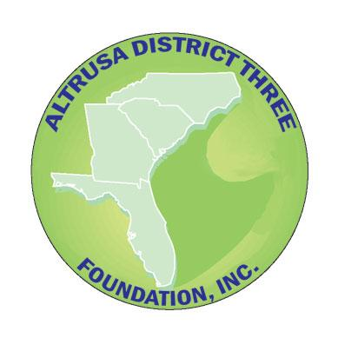
Altrusa District Three Foundation, Inc.
Nomination Form 2022

Club Presidents, District Foundation Trustees, Past Governors or eligible candidates should complete this form for a position on the District Three Foundation Board and return it with a photo (head and shoulders) to:

Altrusa District Three Foundation, Inc. – Board Liaison
Dimple Overstreet Governor-Elect, email address dimplej@embarqmail.com
by January 10, 2022, (904) 964-6768

As outlined in the Bylaws:

- The Board of Directors of the District Three Foundation is comprised of five elected Trustees and one elected Treasurer who are members of Altrusa International, Inc. District Three and are elected by the membership and one non-elected, non-voting member who is the Governor-Elect of Altrusa International, Inc. District Three.

- Each Trustee and Treasurer of the Foundation shall serve for a term of two (2) years. Trustees and the Treasurer may serve no more than three consecutive terms.

- No more than two members from any one club can be elected to serve on the board at any one time.

Nominees for office

To be eligible for election as a Foundation Officer or Trustee, the nominee:

- Must have been a member of Altrusa International, Inc. for a minimum of two (2) years prior to nomination for election, and must have served as club president, club foundation chair or club or foundation treasurer
OR
- Must have been a member of Altrusa International, Inc. for a minimum of five (5) years prior to nomination for election, and must have served on a 501(3)c Foundation Board external to Altrusa.
In addition, to be eligible for election as Foundation Treasurer, the nominee:

    - Must have completed a full term as a local club treasurer, a club foundation treasurer, or be serving as a local club or foundation treasurer at the time of the election, and

  - Must have general accounting knowledge and experience.

Candidate Information

Have the candidate assist in completing the form. Use additional paper if necessary.

(Please print or type)

Nominated for Position of (Trustee or Treasurer):

By:

Name of Candidate:

Past President of Altrusa International, Inc. of:

Altrusan since:

Address:

Phone: (B) (H): (C)

E-Mail Address:

Membership status:

Occupation:

Employed by:

Education:

Club offices and/or chairmanships held, personal initiatives, or achievements:

District offices and/or chairmanships held, personal initiatives, or achievements:

List other community organizations to which the candidate belongs or has active interest. Include offices held:

List community/professional board, committees, councils, etc., Does the candidate serve now or has the candidate served within the past two years? Include offices held:

Professional Experience:

Have the candidate complete this sentence in 50 words or fewer:

In addition to my love for Altrusa, I want to be a District Three Foundation (Trustee or Treasurer) because . . . and would bring to the District Three Foundation Board of Directors (tell what skills, attitudes, beliefs about Board membership, and other pertinent information about your work on a board of directors (the underlined text should not be included in the word count):

I have conferred with the candidate who is willing to serve or if self-nominating, I am willing to make the necessary commitment to the work of the District Three Foundation and to devote the time the office may require.

Signature of the Club President/ District Foundation Trustee/ Past Governor or eligible candidate (electronic signature is acceptable if from an authorized sender):

Date:

Sign:

