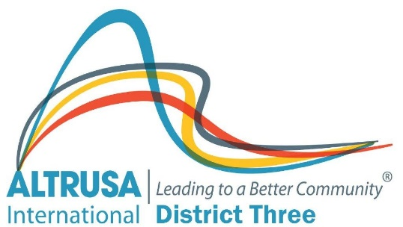

ALTRUSA INTERNATIONAL DISTRICT THREE, INC.
District Three Extension Award

District Three has taken a proactive role in addressing the decline in club memberships by developing a strong plan for club extensions. This plan includes training materials, a support system, and a monetary reimbursement to defray some of the costs incurred when beginning a new club.
The District Three Extension Award, given at the time a new club is chartered, recognizes the supporting club for its efforts to keep Altrusa International a growing organization and to expand awareness of Altrusa as a vital part of the service community. The award system described below supports both growth and expansion. It is important to promote the value of “giving Altrusa away.” Promoting the idea that Altrusa is an outstanding organization for qualified leaders allows us to give away the best we have to offer. Therefore, growth becomes an integral part of our success and clubs’ benefit from the recognition and monetary awards.
Criteria for District Three Extension Award
- Points for time in which club is chartered, in reference to most recent conference
First: 3 points (first club chartered after April 30)
Second: 2 points (second club chartered after April 30)
Third: 1 point (third club chartered after April 30)

- One point for each Charter Member
Example: 15 Charter Members = 20 points 25 Charter Members = 30 points

- One point for each member in the club as of April 1 (immediately prior to Conference)
Example: 24 members = 24 points

- First, Second, and Third place winners receive certificates.
To further explain the rationale behind the point system, we offer the following:
- The District Conference is used as a reference point to encourage clubs considering extension to get busy while what they learned at conference is still fresh in their minds and to make extension a priority for their club.
- The number of members at the time of chartering is used to encourage clubs to charter with more than the minimum 15 members. This gives both clubs an edge. The extending club takes more points into the competition for the Extension Award, and the newly chartered club gains a stronger beginning.
- No additional points are awarded if an extending club builds more than one new club because the numbers of members in the new club(s) at the time of chartering and immediately prior to Conference virtually assures that the extending club will be the winner.
- Chartering clubs are encouraged to maintain contact with and pursue joint activities with the extension club if at all possible.

