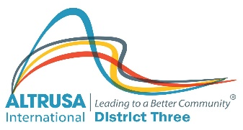
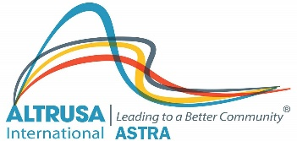
KITTY MCELHANEY ASTRA GRANT FUND

The “Kitty McElhaney ASTRA Grant Fund” was created in 2021 in honor of Governor Kitty McElhaney to provide District Three ASTRA Clubs a source of funding for service projects. The funds are to be made available to all District Three ASTRA Clubs, until the funds are depleted.

Process:
- An ASTRA Club completes an application for no more than $150 and submits to the District Three ASTRA Committee Chair.
- The District Three ASTRA Committee Chair reviews the application and submits to the District Three Board for approval.
- The District Three Board reviews the submission and renders an opinion to fund/not fund the request.
- If the request is approved, the ASTRA Club completes the project evaluation form at the end of the project and submits it to the District Three ASTRA Committee Chair, who forwards it to the District Three Board.
- A District Three ASTRA Club may make a request annually.

ASTRA Clubs applying for a grant must complete the application, including a project budget, indicating the intended use and the benefits of the grant and the application is to be signed by the sponsoring Altrusa Club.
All grant recipients are obligated to use the money for the intended purpose. Future grants for your club are dependent upon a final report being submitted to the current District Three ASTRA Chair.

In developing the narrative of your project, please refer to the Check List below.
- Describe the project.
- Describe how the grant will enable the club to complete the project
- Define the timeline expected to complete the project
- Define how you will evaluate the project at its completion.

KITTY MCELHANEY ASTRA GRANT PROJECT APPLICATION

Submitted by ASTRA Club of _____________________________________________________________
Club Contact _________________________________________ Title ___________________________
Address _____________________________________________________________________________
City _________________________________________ State_________________________ Zip____________
Sponsoring Club: Altrusa International of ____________________________________________________
Name of Project ______________________________________________________________________
Amount of Grant Requested ____________________________________________________________
Contributions by sponsoring club (money or in-kind) ________________________________________
Amount received from other sources _____________________________________________________
Describe on a separate sheet, typed, double-spaced and on one side only, your project and the reason your ASTRA Club would like to apply for a Kitty McElhaney ASTRA Grant allocation (use 500 words or less).
Please sign the acknowledgement below and include in your application packet.
If our club receives a Kitty McElhaney ASTRA Grant allocation, we accept and agree to abide by the following:
- We will use the money for the project for which we are applying
- We will report to the District Three ASTRA Committee Chair how the money was used and the status of our project (Failure to comply will result in ineligibility to receive future grants until the report is received)
- We will make our report to the Altrusa District Three ASTRA Committee Chair least one month prior to the following year District Conference. See the instructions for filing the report.
- We will return all monies not used for the project to the District Three Board
ASTRA Club President _______________________________________ Date_______________

Sponsoring Altrusa Club President_____________________________ Date_______________

District Three Board_________________________________________ Date_______________
- APPROVAL TO FUND

- NOT FUND
Instructions for filing the Final Report of Kitty McElhaney ASTRA Grant Funds

Please use the attached form for the submission of your report. Additional pages may be used if necessary, to fulfill the requirements of the final report. Please return this signed and dated form to the current District Three ASTRA Chair.

We wish to report that Kitty McElhaney ASTRA Grant funds have been used for the above-named project as we outlined in our request for those funds. Listed below is a summary of the use of these funds. The report must be typed, double-space and on one side only. Use additional pages if necessary, for a full accounting.

ASTRA Club President ________________________________________Date _____________________

Sponsoring Altrusa Club President______________________________ Date_____________________

On behalf of the Altrusa District Three Board, we hereby accept the accounting of the use of Kitty McElhaney ASTRA Grant Funds as outlined above and agree that the funds have been administered in accordance with the initial request.

______________________________________________________________ __________________________
District Three ASTRA Committee Chair Date

