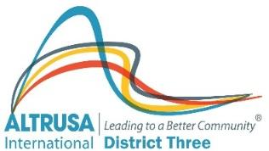
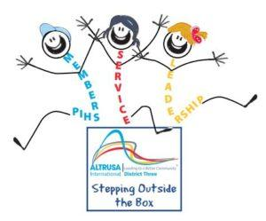
Altrusa International, Inc.
68th Annual District Three Conference
April 22 – 24, 2021
Greenville Marriott
1 Parkway East
Greenville, SC
Conference Registration (One Member Per Form)
Please Print
Name: _______________________________________________ E-mail: ___________________________________
Address: _________________________________________________ Home Club: ___________________________
City _________________________________State: __________Zip: ___________ Phone: _____________________

Dietary Needs: ___ Vegetarian ___ Diabetic ___ Gluten free Other: ______________________________

Conference Booklet/Materials: ___ Paper copy ___ Electronic Version (please check one)

Please check all of the following that apply to you:
___ Member ___ Club President ___ International Officer
___ Delegate ___ Incoming President ___ International Rep
___ Alternate ___ Past Governor ___ Past International President
___ District Officer ___ District Committee Chair ___ First Timer
___ District Foundation Officer
Conference Fees
Please register by April 7, 2021. After that date, a $20.00 late fee will be charged.
Conference fees will be refunded if cancellation is received by April 7, 2021.
Full Conference Registration: ($200 minus $30 District Board 2021 Support = $170)
(Includes Friday Breakfast, Friday Lunch, Friday Fun Night,
Saturday Breakfast and Saturday Governor’s Banquet. ___ $ 170.00 _____
Friday Only Registration: (Includes Breakfast, Lunch, and Friday Fun Night) ___ $ 130.00 _____
Saturday Only Registration: (Includes Breakfast and Governor’s Banquet) ___ $ 135.00 _____
Less First Timer Discount (full registration only, check First Timer’s Column Above) ___ ($ 25.00) _____
Late Registration Fee: (For registrations received after April 7, 2021) ___ $ 20.00 _____
Subtotal Member Registration _____

Guest Tickets for Meals: # of Guests
Name: ______________________ Friday Breakfast ____ @$27.00 _____
Name: ______________________ Friday Lunch ____ @$30.00 _____
Name: ______________________ Friday Fun Night ____ @$45.00 _____
Name: ______________________ Saturday Breakfast ____ @$27.00 _____
Name: ______________________ Sat. Governor’s Banquet ____ @$55.00 _____
Subtotal Guest Registration _____
Grand Total Registration _____

Make Checks to: Altrusa District Three Conference 2021 Conference Hotel: Greenville Marriott
Mail to: Altrusa District Three Treasurer 1 Parkway East
c/o Mary Kirley Greenville, SC 29615
6015 Winter Lane $129 until 5 pm April 7, 2021 (or block of rooms is filled)
Dawsonville, GA 30534 To make hotel reservations, hold down your “CTRL” key and click link below or call:
Book your group rate for Altrusa International District Three Conference
For phone reservations call 1-864-297-0300 and ask for group rate for Altrusa International

Questions? Colleen Duris cmdaltrusa@gmail.com or Frances Ferguson gatordavid1@hotmail.com

